Name: Class: Mark:

1. Computer software that harms computers, networks or data is known as malware.
Describe two different types of malware that exist. [6]

2. Study the email on the following page
State three reasons which indicate that it is a phishing scam. [3]
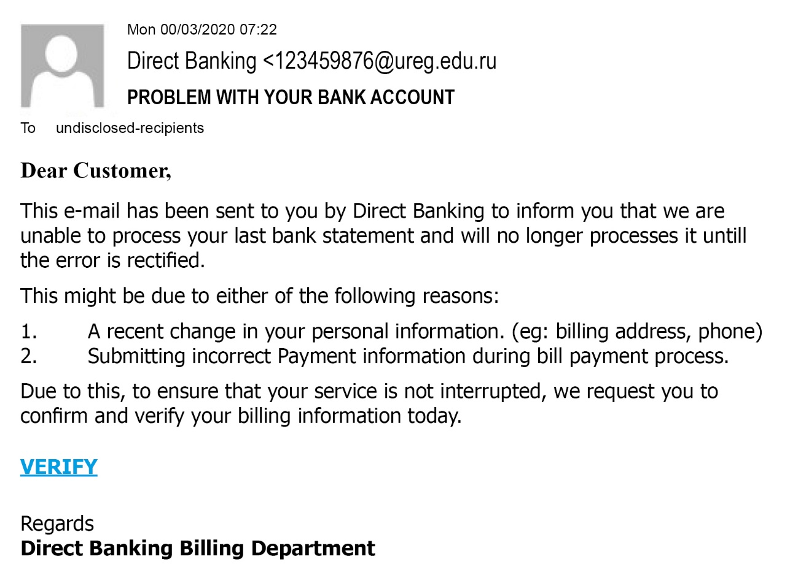

3. (a) Describe what is meant by a distributed denial of service attack. [2]

(b) Indicate in the right-hand column whether each of the following statements about a distributed denial of service attack is true or false. [4]
True or False
It aims to block an individual’s email account
The aim of the attack is to spread misinformation about an organisation
The motive is often black mail or revenge
It may cause the victim’s network to crash

[Total 15 marks]

